**Weather App Project Documentation**

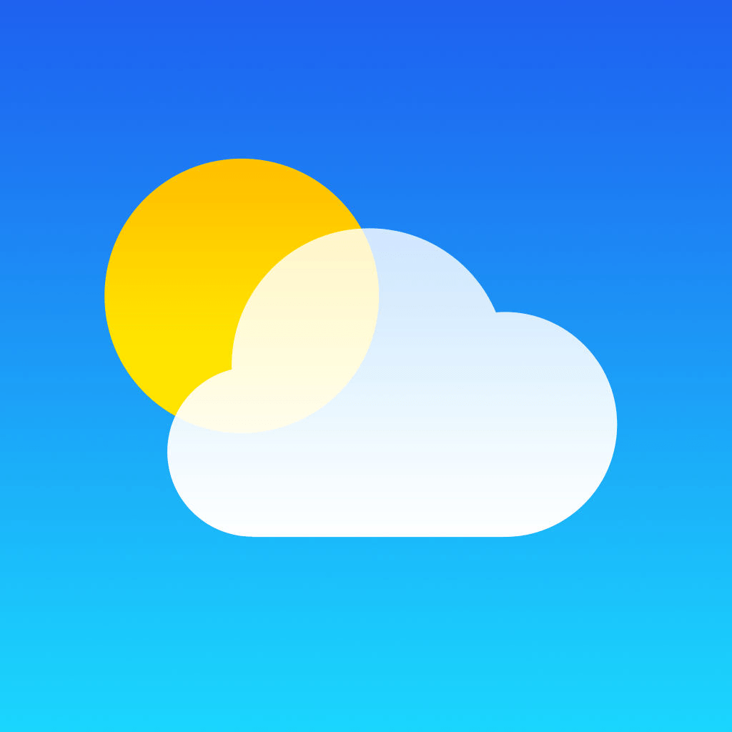

Rahul Sharma

[rahultechip@gmail.com](mailto:rahultechip@gmail.com)

<https://github.com/mr-rahul-sharma>

<https://www.linkedin.com/in/rahul-2/>

**Contents**

|  |  |
| --- | --- |
| **Sr. No.** | **Topic** |
| 1 | Brief Summary |
| 2 | Introduction |
| 3 | Related Work |
| 4 | Problem Definition |
| 5 | Objectives |
| 6 | Proposed Technique |
| 7 | Results |
| 8 | Conclusion |
| 9 | References |

**Brief Summary**

* Project is related to **Weather App**
* This project show weather information of your location.
* Main facilities available in this project are:
  + Temperature
  + Pressure
  + Humidity
  + Sunrise Time
  + Sunset Time
  + Clouds
  + Wind Speed
  + Current Details and 5-day weather forecast
  + Hourly Forecast also available
* Instant Details
* Weather can be searched by city name.
* Implemented as web application. So that, can be used anytime and anywhere.
* Implemented using Django Framework.

**Introduction**

Weather App is a web-based application through which you will able to get all the reports related to weather forecasting of any locations.

How to get weather information:

* Open your browser.
* Go to the website.
* It will show details of your location.
* Further, you can search details of a city.
* Type your city name in search box and hit enter.
* Current weather status, 5-day forecast and hourly forecast details will be shown on screen.
  + Temperature
  + Pressure
  + Humidity
  + Sunrise Time
  + Sunset Time
  + Clouds
  + Wind Speed
* The results will be shown very quickly.
* Access current weather data for any location including over 200,000 cities.
* We collect and process weather data from different sources such as
  + Global and local weather models
  + Satellites
  + Radars
  + A vast network of weather stations
* Data is available in JSON, XML, or HTML format.

**Related Work**

The weather apps, which are already present in market, has to be downloaded on device to get weather information.

Also, in some cases, these apps show weather status only for default cities based on location.

And some apps show only few details about weather.

The existing apps are very heavy and consumes a lot of data.

**Proposed Weather Application:**

The new weather app is web-based application. So that, it can be used anytime and anywhere. Also, the app is very light-weight application and don’t consume a lot of data.

* A large number of locations are included over 200,000 cities.
* A variety of information will be available and not only for current time, but also for next 5 days.

The app is free to use. You can search for a specific city detail.

The application has simple user interface.

**Problem Definition**

The existing weather application has many problems, such as

* The existing application has to be downloaded on device to get weather status.
* Shows weather status only for default cities based on location.
* Many features are premium and very costly.
* Applications are very heavy.
* Consumes a lot of data.
* Not immediate update in details.
* A very complex user interface.
* Shows only few details.
* In some applications, you first have to create an account to get weather details.

Thus, to overcome these problems, a new web-based solution is proposed.

And, new application is very easy to use and very effective.

**Objectives**

* **Planned approach towards working:** The working in the organization will be well planned and organized. The data will be stored properly in data stores, which will help in retrieval of information as well as its storage.
* **Accuracy:** The level of accuracy in the proposed system will be higher. All operation would be done correctly and it ensures that whatever information is coming from the centre is accurate.
* **Reliability:** The reliability of the proposed system will be high due to the above stated reasons. The reason for the increased reliability of the system is that now there would be proper storage of information.
* **No Redundancy:** In the proposed system utmost care would be that no information is repeated anywhere, in storage or otherwise. This would assure economic use of storage space and consistency in the data stored.
* **Immediate retrieval of information:** The main objective of proposed system is to provide for a quick and efficient retrieval of information. Any type of information would be available whenever the user requires.
* **Easy to Operate:** The application should be easy to operate and should be such that it can be developed within a short period of time and fit in the limited budget of the user.

**Proposed Technique**

The Weather App is a web application.

|  |  |
| --- | --- |
| Programming Language | Python |
| Web Framework | Django |
| Database | No need |
| Web Languages | HTML, CSS, JavaScript |
| API Used | <https://openweathermap.org/current> |
| Data Format | json |
| Project Location | <https://github.com/mr-rahul-sharma/climateinfo> |
| Project Website | <https://climateinfo.herokuapp.com> |

Project location and website may be unavailable.

**Result**

Here are some screenshots of the **Weather App.**

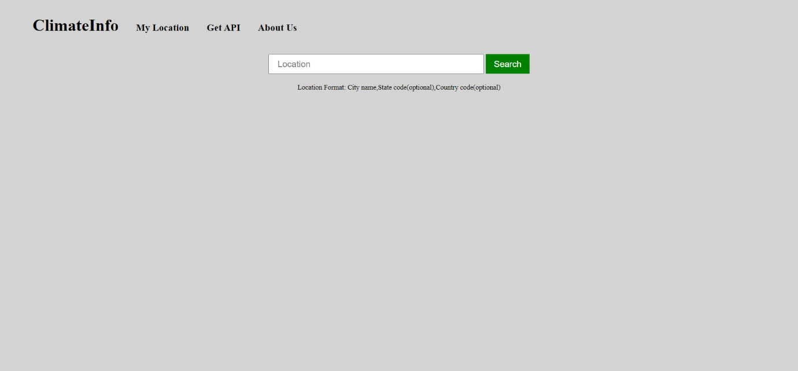

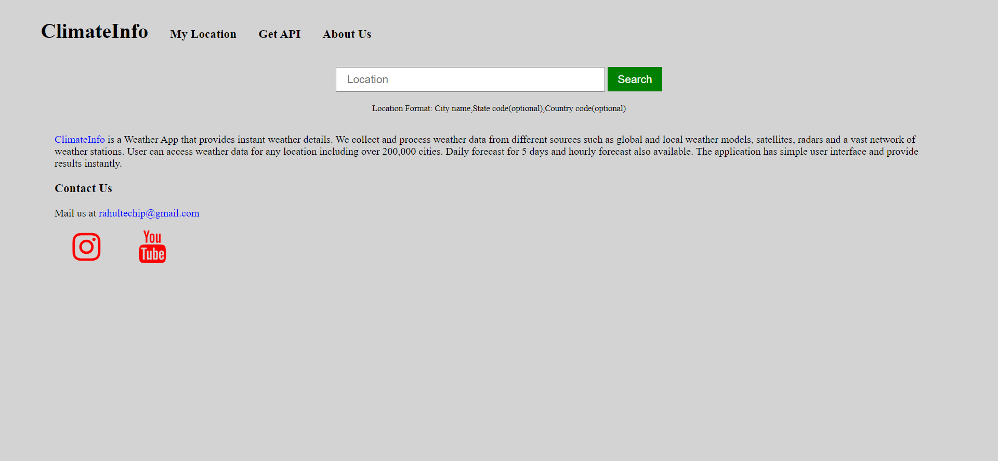

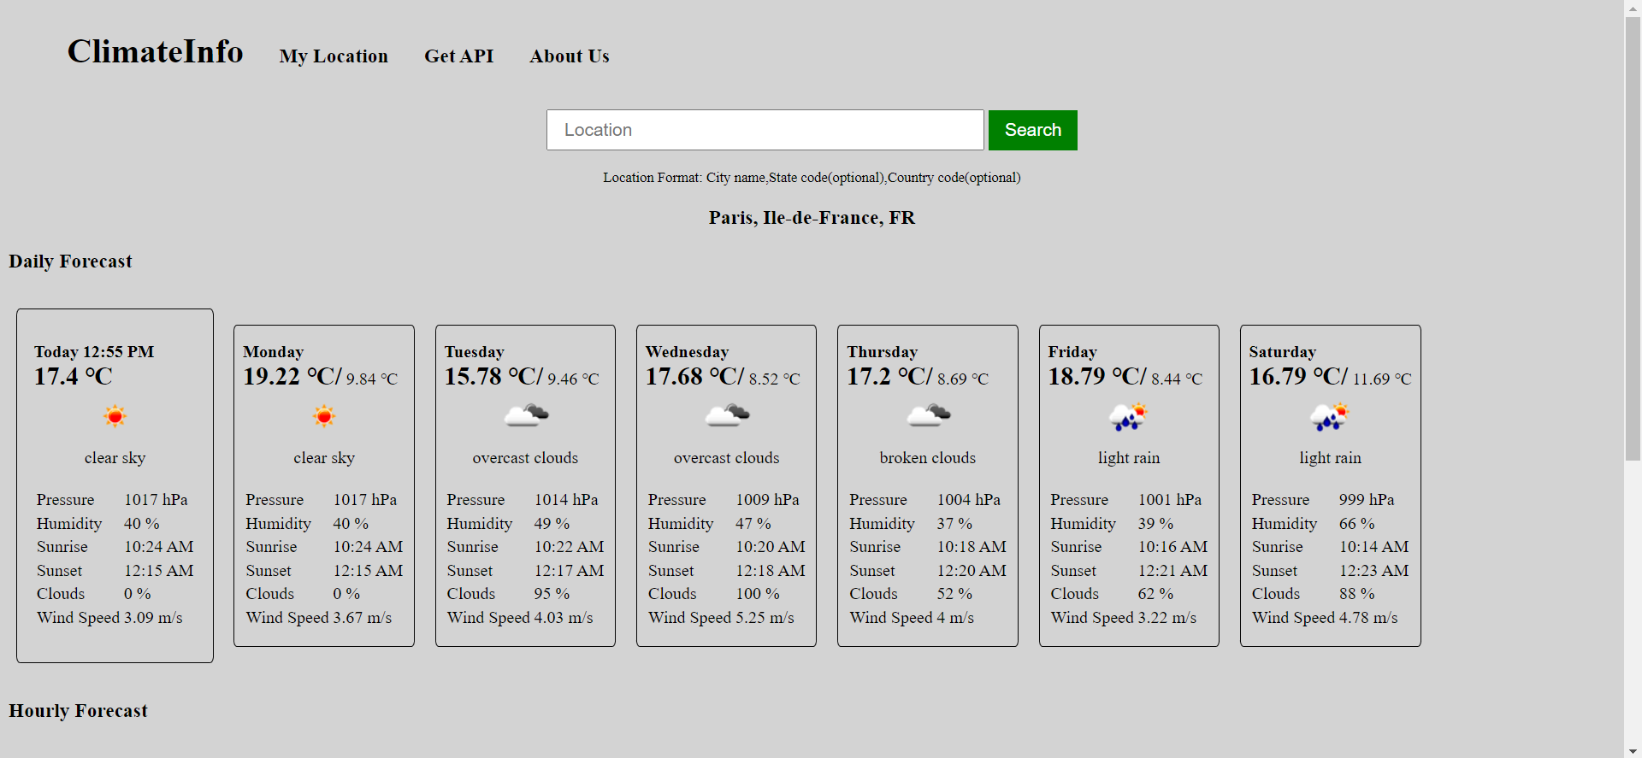

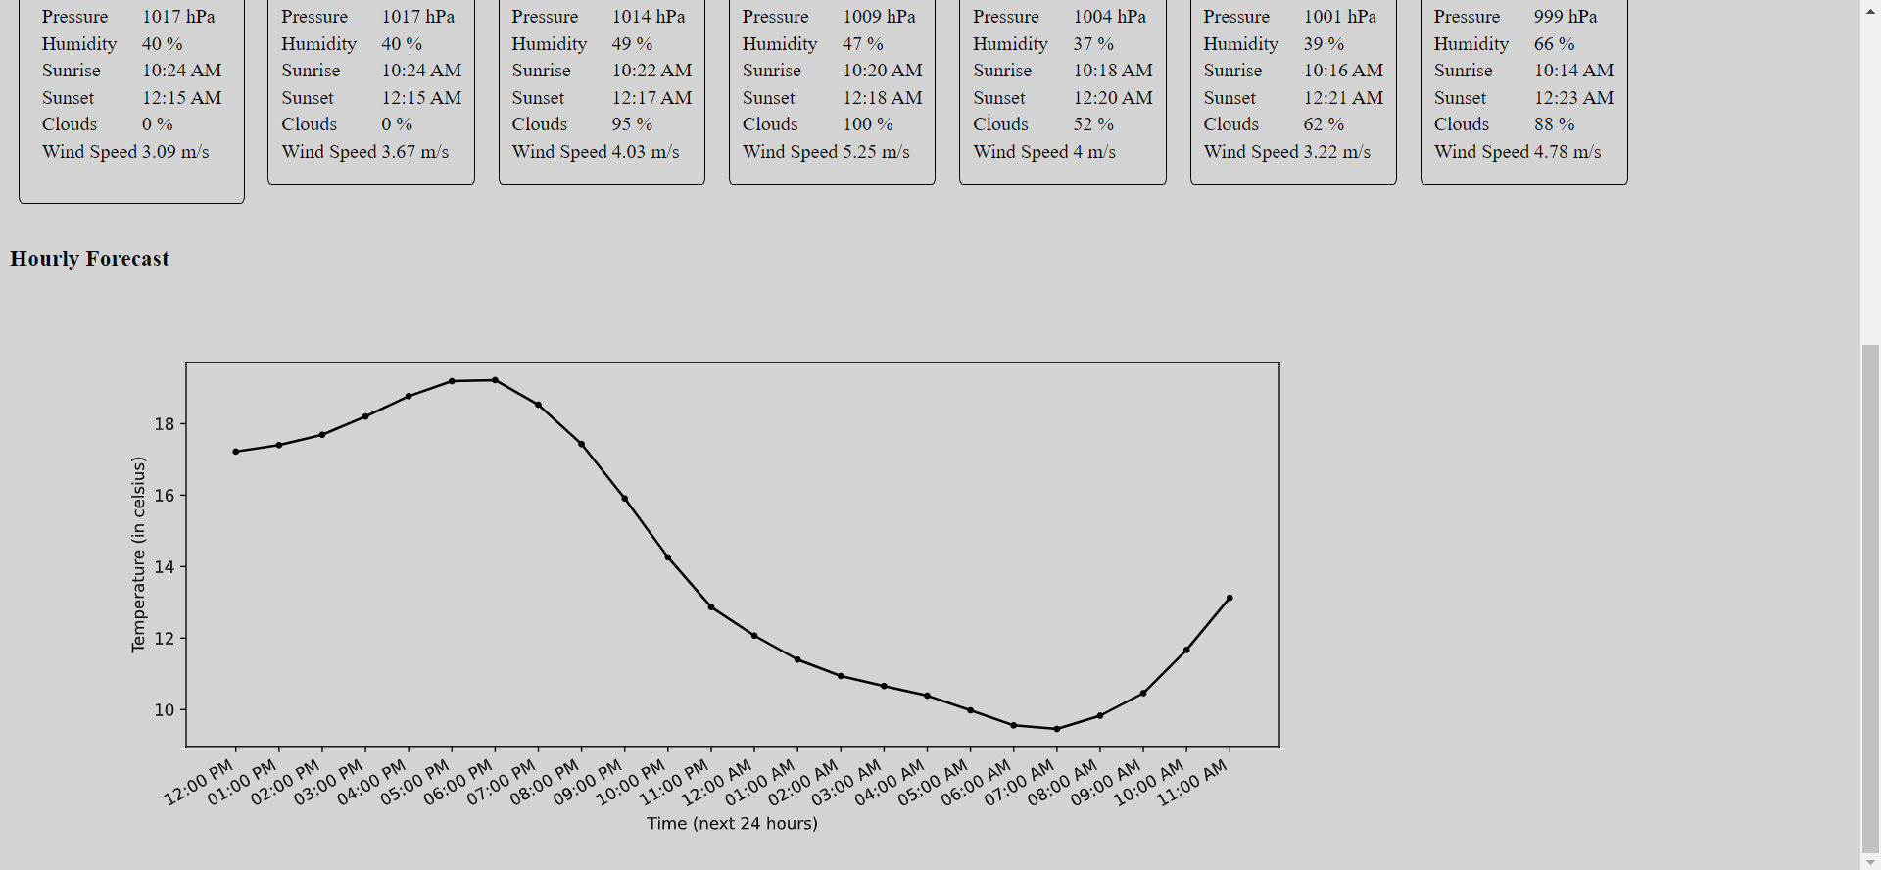

**Conclusion**

The Weather App is an application which provides current weather details of your location. The application has a very simple user interface. So that, it can be used by any user.

The app uses API of <https://openweathermap.org/>api

and is developed using Django Framework.

Following weather status will be shown on screen.

* + Temperature
  + Pressure
  + Humidity
  + Sunrise Time
  + Sunset Time
  + Clouds
  + Wind Speed

Details available not only for current time, but also for next five days.

You can search a specific city detail.

The application has simple UI.

**References**

<https://docs.python.org/3/>

<https://docs.djangoproject.com/en/3.2/>

<https://openweathermap.org/current>

<https://medium.com/analytics-vidhya/weather-app-in-django-1a12b1fbf52c>